BOCCIA TATRA CUP 2016

National and International
Individuals Boccia Tournament
2nd annual

From 25 to 27 June 2016, the 2nd edition of National and International Individuals Boccia Tournament - Boccia Tatra Cup (BTC) – takes place in the sports hall of the Alexandra Hotel in Liptovský Ján. Boccia is a paralympic sport, based on the principle of throwing balls at the target. The main organizer of the tournament is ZOM Prešov - Civil Association of People with Disabilities (www.zompresov.sk).

The tournament is divided into national part, which takes place on June, 25 and international part, which takes place from 26 to 27 June 2016.

National BTC Tournament is part of the national tournaments season, organized for boccia athletes at the national level and is aimed at the sportsmen of all categories, from BC1 to BC 4. The results in the tournament will be added into the overall Slovak classification.

International BTC Tournament is a friendly, non-ranking tournament, bringing together Slovak and foreign participants. This year, the tournament will host 53 players from 7 countries: Slovakia (15), Czech Republic (10), Hungary (12) United Kingdom (8), Croatia (4), Poland (3), Ukraine (1). The players will compete in every category aimed at individual players, from BC1 to BC4.

The quality of the tournament is ensued by the participation of top players in the World rankings, including nimi Róbert Mezík, SVK BC2 (5), Samuel Andrejčík SVK BC4 (11), Róbert Ďurkovič SVK BC4 (12) a Kateřina Cuřínová CZE BC1 (16).

Last year, the BTC organizers set a target to establish a tradition of international tournament in our region, which has been met when organizing the second edition of the tournament. The establishment of international boccia tournament in Slovakia is really a great achievement. Although our boccia representation is very successful, most Slovak players rarely get chance to challenge foreign players. For many boccia players, the opportunity to play against someone else than commonly used to in competitions organized at national level is a rewarding experience.

International tournament consists of group stage and the finals. The sports hall is adapted in accordance with the needs of disabled people. The tournament will be held at 7 courts, on the laminate flooring surface. Accommodation is provided in Alexandra Wellness Hotel, Sorea Máj and Sorea Ďumbier and in Liptovský Ján (all within the reach of 3 km from the sports hall.)

From June 27 to July 3,.2016, a sports and reconditioning stay "Boccia Holiday" is planned and participants can joint training sessions, informal meetings, sports camps, go to wellness, rehabilitation, on excursions, or visit cultural and social events.

Program of the event:

Day | Date | Time | Activity
Friday | 24.6.2016 | 8:00 | Arrival of rhe organizers, preparatory stage
Saturday | 25.6.2016 | 9:00 – 16:00 | National BTC Ranking Tournament
Sunday | 26.6.2016 | 9:00 – 18:30 | International BTC Tournament (group stage)
Monday | 27.6.2016 | 9:00 – 16:00 | International BTC Tournament (finals)
Mo – Su | 27.6.-3.6.16 | 8:00 – 22:00 | Trainings, trips, wellness, free time

Referees (National tournament):

Matúš Grega – main referee; Katarína Králová, Mária Lenártová, Vladimíra Balcová, Ľudmila Andrejčíková, Jarmila Malíková, Jozef Fejerčák, Ľuboš Kondela

Referees (International tournament):

Matúš Grega – main referee; Mária Lenártová, Vladimíra Blacová, Ľudmila Andrejčíková, Jarmila Malíková, Jozef Fejerčák, Ľuboš Kondela, Marián Klimčo, Pavla Vrbová (CZE), Monika Doskočilová (CZE), Dominika Rěpková (CZE), Ivan Begic (CRO), Joel Komar (CRO), Branko Ivanešić (CRO)

Organizer:

The Chief of the Tournament: Boris Klohna
Deputy Chief and administration: Mgr. Ondrej Bašták Ďurán
Sound: Jozef Sirotňák

Graphic design of press materials:

PICTUS graphic studio, Prešov - PaedDr. Anna Mačová

Main partner:

Visegrad Fund, in Small Grants Pogram, (www.visegradfound.org)
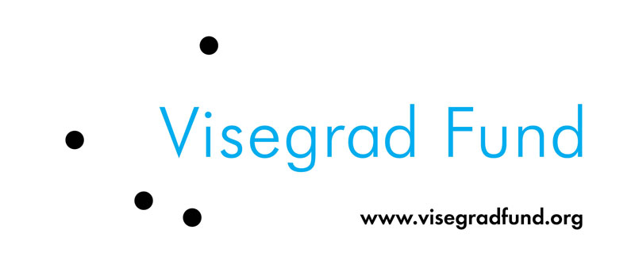

Partners of the project:

Sportovní club Jedličkova ústavu Praha, Česká Republika
FODISZ - Fogyatékosok Országos Diák-és Szabadidősport Szövetsége, Maďarsko
PROMETEUS - Stowarzyszenia Osób Niepełnosprawnych Ruchowo ich Rodzin i Przyjaciół, Poľsko

Sponsors:

- Visegrad Fund
- Slovenský zväz telesne postihnutých športovcov
- IMA – Ideálna mládežnícka aktivita
- Nadácia Jána Korca
- Nadácia HB Reavis
- Minerálne vody, a.s.
- Mesto Liptovský Mikuláš
- Agro Fruit, s.r.o.
- Ekofarma Važec

Contact:

ZOM Prešov - občianske združenie ľudí so zdravotným postihnutím (športový klub), Karpatská 18, 080 01 Prešov, Slovakia, www.zompresov.sk, zompresov@zompresov.sk, ++421517701499, ++421908487603, ++421904596079
